Architecture Case Study: VinaBeef RFID Livestock Platform
- Author(s): Based on the VinaBeef M1 architecture report (HCMUT Software Architecture, October 2026), analysed with the same template as the Tesla fleet case study
- Date: 2026-10-28
- Status: Draft
- Domain / Product Area: Livestock farming, IoT edge platform
In this case study, OTA (over-the-air) management means changing what runs at the 240 barn gates without sending a technician: the cattle whitelist and the reader configuration.

1. Executive Summary & Context
VinaBeef tracks about 25,000 cattle across 3 farms (Dak Lak, Gia Lai, Dong Nai), 120 barns and about 240 RFID gates. This case study shows how three architectural choices meet the pressure of keeping an accurate, traceable herd record on farms with unreliable internet: OTA management of the gate nodes, an event-driven backbone with edge store-and-forward, and a zero-trust principle applied through device certificates and scoped access checks.

1.1 Business Drivers
The traceability problem. When cattle are counted by hand, a missing or sick animal is noticed late, and its contacts cannot be traced.
- Daily operations (VinaBeef today): manual headcounts cause counting errors and delays in detecting missing animals, and paper health records risk livestock loss and food-safety violations.
- 240 gates in 3 provinces: if every whitelist or reader change needs a technician on site, the herd record at the gates goes stale within days.
Two drivers follow: every movement must be captured automatically, even when the farm network is down, and the gates must be kept up to date remotely and safely by a small IT team.

1.2 System Scope & Boundaries
How the system works today (as designed in M1). Every animal wears an ISO 11784/11785 ear tag. Each barn gate is a narrow chute with one RFID reader and two antennas, INNER and OUTER, so the order of the two reads tells the direction: out to pasture or into the barn. A Gate Reader Node beside the gate checks each scan against a local copy of the farm's cattle whitelist and saves the movement in a local queue. When the network is up, the node forwards events to a Kafka broker in the central data center, where services count cattle per barn, detect missing, unregistered or wrong-barn animals, and send alerts. Three things travel between gate and center: movements and heartbeats go up; the whitelist and reader configuration come down over the air; and people's requests (register an animal, replace a tag, change a reader) enter through an API gateway that checks who they are and which farm or barn they may touch.
Scope of this case study: the gate edge, the movement and alerting pipeline, the over-the-air distribution of whitelist and configuration, and the security path. Health records, report formats and the data model are covered only where they touch these flows.

2. Architectural Drivers & Quality Attribute Scenarios (ASRs)
Targets come from the M1 report (NFR-01 to NFR-03 and Table 3.1). The load is small: about 50,000 movements a day, roughly 0.6 events per second on average and under 5 per second at peak. So the drivers are correctness, durability and trust, not throughput.
Quality Attribute | Stimulus / Source | Environment | Artifact | Expected Response | Response Measure
Performance | An animal passes a gate | Peak: about 200 cattle per 30 minutes per farm | Gate Reader Node | Scan checked against the local whitelist and recorded, with no call to the data center | ≤ 2 s per read (NFR-01)
Durability | Farm WAN goes down | Normal operation | Local event queue and broker | Gate keeps recording; queue forwards events when the link returns | No movement record lost (NFR-02)
OTA deployability | A new animal is registered, or a reader's settings change | Normal operation | Whitelist and configuration distribution | Change reaches every gate of that farm over the air; a reconfigured reader goes back to Commissioning | Whitelist updated in about 10 s; reader is Online only after a passed test read
Security | A stolen gate node, or a supervisor of farm A editing farm B | Production | Broker, API gateway, business layer | Request rejected; device certificate can be revoked | Zero unauthorised writes; every denial logged (NFR-03)
Data integrity | Two tablets assign the same tag at the same moment | Peak tagging | Registry database | Second assignment rejected | No tag active twice or reused
Availability | One server or pod fails | Normal operation | Central services | Work continues on the remaining instance or standby | ≥ 99.5% for central services (proposed in M1)

2.1 Technical & Operational Constraints
Constraint | What it means | Effect on the architecture
Intermittent farm WAN | Barns cannot rely on reaching the data center | Gates decide locally and buffer events; the whitelist lives at each gate
ISO 11784/11785 tags | 15-digit IDs with country code 704 | Gate software and APIs validate the same format
One active tag per animal | A tag number is never reused | Uniqueness enforced by database constraints, not only in code
Small IT team | Few people to run servers and visit gates | A handful of services on a shared platform; gates managed over the air
Disease reporting | Health data must reach the national NADCS system | An outbound plug-in sends data; NADCS never becomes a dependency of farm operations

3. Candidate Architectures & Trade-Off Analysis
At system level the M1 report already chose a service-based architecture (one coarse service per business area) over a layered monolith and microservices (Table 3.2). The decision that matters for the gates is how they talk to the center, compared here as two options.

3.1 Option A: Central, synchronous gate processing
- Summary: each gate sends every scan to a central REST API, which checks the tag and records the movement; reader settings are changed on each node by hand.
- Key advantages:
  - Simple to build and test; one source of truth, always up to date
  - No broker, outbox or local database to operate
- Architectural trade-offs & risks:
  - Every scan needs the WAN: an outage stops recording and loses movements
  - Response time depends on the network, not the gate
  - 240 nodes to update by hand when readers change

3.2 Option B: Edge-first, event-driven, with OTA-managed gates
- Summary: each gate checks scans against a local whitelist and queues movements locally; events flow through Kafka to the central services; whitelist and reader configuration are pushed to the gates over the air, versioned.
- Key advantages:
  - Gates keep working offline and answer locally
  - Changes reach all gates of a farm in about 10 seconds without site visits
  - New consumers (for example, a new alert type) subscribe without changing the gates
- Architectural trade-offs & risks:
  - Eventual consistency: a gate may briefly check against an old whitelist
  - More infrastructure: Kafka, outbox relay, local SQLite on every node
  - Harder to trace a single movement end to end

3.3 Evaluation Against Drivers and ASRs
Driver / ASR | Option A: central, synchronous | Option B: edge-first, event-driven, OTA
Performance (≤ 2 s per read) | Partly: fine on a good network, fails when the WAN is slow | Meets: local check, no network in the read path
Durability (no lost records) | Fails: scans during an outage are lost | Meets: local queue plus durable broker
OTA deployability | Fails: whitelist is always fresh, but reader changes need site visits | Meets: versioned whitelist and configuration pushed in about 10 s
Security | Partly: user checks at the API; gates are just clients | Meets: per-device mTLS certificates, topic permissions, scope checked twice
Data integrity | Same: enforced by database constraints in both | Same
Availability (gates during outages) | Fails: gates depend on the center | Meets: gates record during outages
Driver: small IT team | Better: fewer moving parts | Worse: broker and outbox to operate, though gates need no visits
Result: Option B meets five of the seven criteria and ties on one. Its cost is operational: more infrastructure for a small team, and short windows where a gate's whitelist is stale. The M1 design handles the stale case by marking such alerts provisional until the central check confirms them.

3.4 Decision Synthesis & ADR Reference
- Selected baseline: Option B.
- ADR links (M1 report): AD-1 and AD-2 in 6.2.6 (event-driven, store-and-forward at the edge); AD-8 and AD-9 in 6.1.6 (transactional outbox, whitelist cached at each gate); AD-5 in 6.1.6 (versioned reader configuration with commissioning); AD-4 in 6.1.6 and AD-1 in 6.5.6 (security through the shared gateway).

4. Target Architecture & Structural Design

4.1 Design Principles
With Option B selected, four principles from the M1 report (Chapter 7) carry the design. Each is shown against what happens without it.
Principle (M1 ref.) | Without it | With it at VinaBeef
The gate never depends on the network (P4) | A WAN outage stops counting and delays gate decisions | Each gate checks scans against its own whitelist and queues events locally
Never lose a record (P5) | Movements during outages or crashes disappear | Store-and-forward at the edge, transactional outbox, durable broker, no physical deletes
Device state is explicit, versioned and verified (P15) | A wrong setting (swapped antennas) silently records IN as OUT | Whitelist and reader configuration are versioned; a reader goes Online only after a passed test read
Never trust the channel (P10, P12) | One stolen node or one leaked password can write anywhere | Per-device mTLS certificates limited to their own topics; users' farm and barn scope checked at the gateway and again in the service

4.2 Logical View
The logical view shows what the system is made of: the main components, grouped by where they run, and which depends on which.
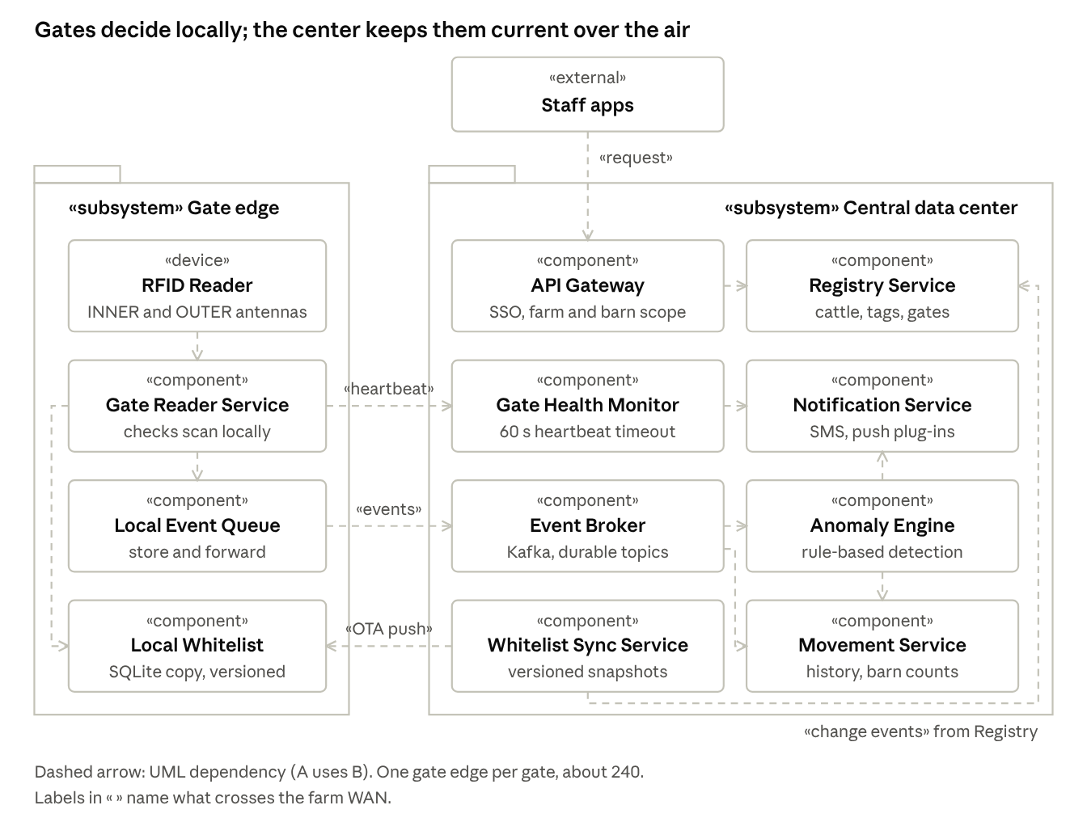
Logical view · UML package and component diagram
Every gate decision has its parts at the gate: the reader, the Gate Reader Service, the local queue and the local whitelist. The center keeps them current: Whitelist Sync pushes changes from the Registry over the air, and the Gate Health Monitor watches heartbeats. Staff never talk to a gate directly; they change the Registry through the API Gateway.

4.3 Component-and-Connector View
The component-and-connector view shows how components interact at runtime: their ports and the connector types between them.
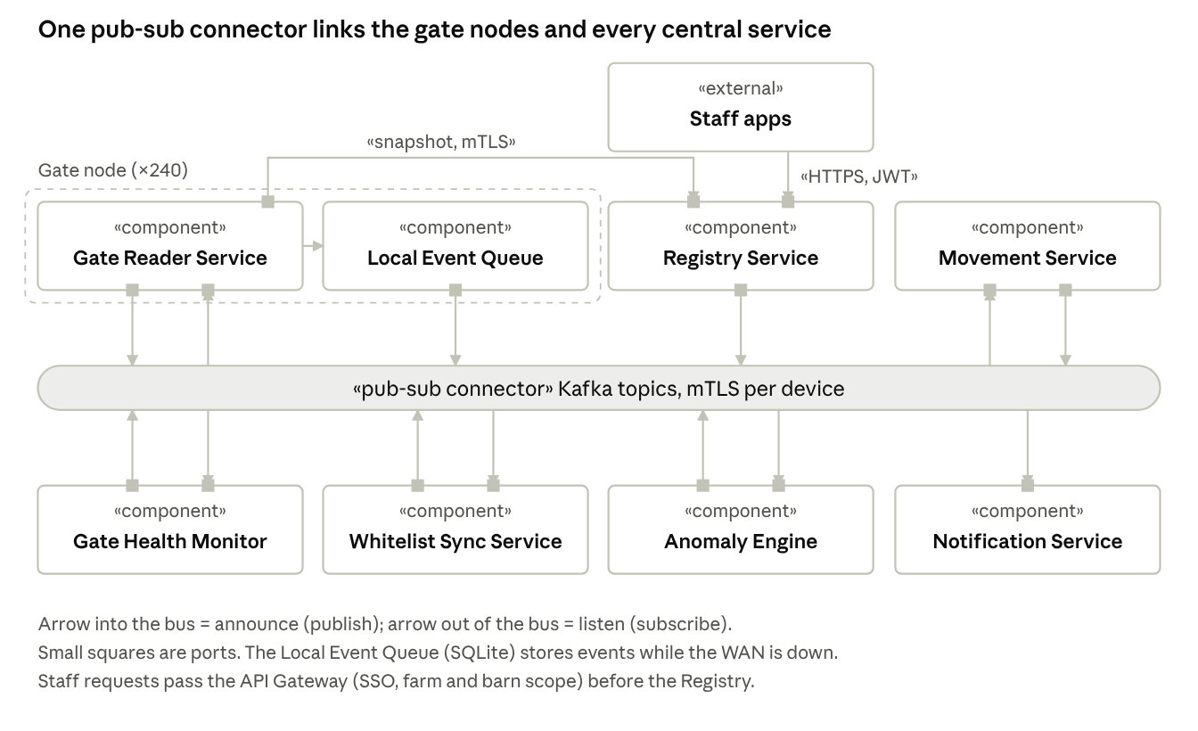
Component-and-connector view · runtime components, ports and the Kafka connector
The key connector is the publish-subscribe connector (Kafka). Gates are both announcers (movements, heartbeats) and listeners (whitelist updates), so the same connector carries data up and over-the-air changes down. The only point-to-point connectors are staff requests to the Registry and the full whitelist snapshot a new or restarted gate downloads.
Topic | Announced by | Listened to by
Movement events | Local Event Queue (gate node) | Movement Service, Anomaly Engine
Count updates (Count_Updated) | Movement Service | Anomaly Engine
Heartbeats | Gate Reader Service (gate node) | Gate Health Monitor
Registry changes (cattle, tag, barn, reader) | Registry Service, through its Outbox Relay | Whitelist Sync Service
Whitelist and configuration updates | Whitelist Sync Service | Gate Reader Service of each farm's gates
Alerts (Abnormality_Alert) | Anomaly Engine | Notification Service
Gate status (GateOffline, GateOnline) | Gate Health Monitor | Notification Service

4.4 Cross-Cutting Technical Decisions
Concern | Decision
Data ownership | Shared PostgreSQL cluster with one schema per subsystem; only the owner writes, others read through views
Communication | Kafka events with a unique event ID and version; REST over HTTPS for staff; Edge Snapshot API for a full whitelist
Resilience | Local queue at each gate, transactional outbox, idempotent processing by event ID, 60-second heartbeat timeout, dead-letter queue for failed notifications
Identity & security | Keycloak SSO with role, farm and barn in the token, checked at the gateway and again in the service; revocable per-device mTLS certificates; append-only audit log

4.5 Over-the-Air Management of the Gates
The M1 design manages the gate's reference data and configuration over the air, so neither needs a technician on site.
OTA layer | What changes | How it reaches the gate | Safety mechanism | Status
Reference data (whitelist) | New animals, tag replacements, expected barn | Outbox → Kafka → gate; full snapshot on start | Versioned; each gate reports the version it applied; alerts from a stale gate stay provisional | In M1 design
Configuration (reader) | Antenna settings, duplicate-read window | New configuration version pushed to the gate | Reader returns to Commissioning; goes Online only after a passed test read; previous version stays active on failure | In M1 design

5. Migration Strategy & Technical Governance

5.1 Rollout & Migration Pattern
The M1 report designs the target system but does not define a migration strategy from manual counting to RFID. Inside the design, reader changes follow a controlled path: a reconfigured reader returns to Commissioning and goes Online only after a passed test read.

5.2 Architectural Fitness Functions & Guardrails
What a fitness function is. A normal test checks a feature ("registering an animal works"). A fitness function is an automated check of an architectural property, run on every build or release so the architecture cannot quietly erode. For example: "a gate must still recognise animals when the WAN is cut." The term comes from Building Evolutionary Architectures (Ford, Parsons and Kua). In Software Architecture in Practice terms, each one turns a quality attribute scenario into a repeatable test.
The M1 report already lists how each requirement is checked (Table 6.5). Several of those checks are fitness functions waiting to be automated.
Property (Section 2) | Fitness function (automated check) | In the M1 report?
Durability / offline: gates work without WAN | Cut the WAN in a test rig; the gate still recognises animals and no queued event is lost after reconnect | Yes, as a manual check (Table 6.5)
OTA deployability: whitelist reaches gates fast | Register an animal; assert every gate of that farm has it within about 10 s | Yes, as a manual check (Table 6.5)
Verified configuration: no swapped antennas | Commission a reader with swapped antennas; it must not become Online | Yes, as a manual check (Table 6.5)
Data integrity: one active tag per animal | Assign an already active tag from two clients at once; one must be rejected | Yes, as a manual check (Table 6.5)
Security: scoped access | A farm A supervisor tries to edit farm B; expect 403 and an audit entry | Yes, as a manual check (Table 6.5)

6. Architectural Evaluation & Long-Term Retrospective
VinaBeef is at design stage (Milestone 1), so there are no production results yet. This section evaluates the design against each scenario: is there a mechanism that meets it, and how will it be verified?

6.1 Results vs. Quality Attribute Scenarios
Key results
- Every driving scenario has a concrete mechanism in the design, from local whitelist checks (≤ 2 s) to store-and-forward (no lost records).
- Whitelist and reader configuration reach all gates of a farm in about 10 s over the air, versioned and verified.
- Main open point: availability of the shared database and gateway still needs failover testing.
Scenario | Target (Section 2) | Mechanism in the design | Verdict
Performance | ≤ 2 s per read | Local whitelist check; no network in the read path | Met by design; confirm with a load test
Durability | No lost movements | Local queue, outbox, durable broker, idempotent event IDs | Met by design
OTA: whitelist and configuration | About 10 s; verified readers | Outbox → Kafka → gate; versioned configuration with commissioning | Met by design
Security | No unauthorised writes; all denials logged | SSO with scoped roles checked twice; per-device mTLS; append-only audit | Met by design
Data integrity | No duplicate or reused tags | Unique and partial-unique database constraints | Met by design
Availability | ≥ 99.5% central; gates work offline | Two pods per service, PostgreSQL standby, three Kafka brokers, offline gates | Partly: the shared database and gateway still need failover tests

6.2 Total Cost of Ownership (TCO) & Operational Load
- Infrastructure cost impact: one shared PostgreSQL cluster, one shared Kafka cluster, Keycloak and a small Kubernetes cluster serve all five subsystems. Storage stays small: movements grow by about 3.65 GB a year, audit and health data by under 100 MB a year each.
- Team cognitive load & velocity: a handful of coarse services suits a small IT team. The heaviest operational item is not the central services but the 240 edge nodes: whitelist and configuration OTA avoid most site visits.

6.3 Accepted Technical Debt & Evolution Triggers
- Accepted concessions:
  - Kafka is heavy for a peak under 5 events per second; it is accepted for durability and reuse of the shared platform
  - A gate may briefly check against an old whitelist; resulting alerts stay provisional until confirmed centrally
  - All subsystems depend on one shared PostgreSQL cluster, mitigated by a synchronous standby

Sources
- VinaBeef team, RFID-based Livestock Farm Management System, Software Architecture M1 report, Ho Chi Minh City University of Technology, October 2026 (all VinaBeef requirements, figures and decisions)
- Architecture Case Study: Tesla Vehicle Fleet Platform (companion report, same template)
- Bass, Clements and Kazman, Software Architecture in Practice (quality attribute scenarios, tactics, patterns)
- Ford, Parsons and Kua, Building Evolutionary Architectures (fitness functions)

